Membership Payment System - Flowcharts
SYSTEM FLOWCHARTS
WEB APPLICATION
Process Flows & System Architecture
Prepared by:
Sunsys Technologies Pvt Ltd
Version: 1.0
Date: January 2026

TABLE OF CONTENTS

1. System Overview ........................................... 3
2. Technology Stack .......................................... 3
3. Complete System Flowchart .......................... 4
4. Payment Logic Flowchart .............................. 7
5. Membership Year Rules ............................... 10
6. Database Schema ........................................ 11
7. API Endpoints ............................................... 12
8. User Journey ................................................ 13

1. SYSTEM OVERVIEW
This document provides comprehensive flowcharts for the Membership Payment System web application. The system enables users to search for members, view their details, and process membership payments with automatic year-wise validation.

1.1 Key Features
• Member Search: Quick search by name with instant results
• Member Verification: Display complete member details including Folio Number
• Sequential Payment Validation: Ensures no membership years are skipped
• Payment Gateway Integration: Secure online payment processing
• Automatic Membership Activation: Instant activation upon successful payment

2. TECHNOLOGY STACK
Layer | Technology
Frontend | React with Vite (JavaScript framework for UI)
Backend | Node.js (Server-side API and business logic)
Database | MySQL (Relational database for member and payment data)
Payment Gateway | Razorpay / Stripe (Secure payment processing)

3. COMPLETE SYSTEM FLOWCHART
This flowchart illustrates the complete end-to-end flow across Frontend (React), Backend (Node.js), and Database (MySQL) layers. The diagram shows how data flows between different system components during member search, verification, and payment processing.

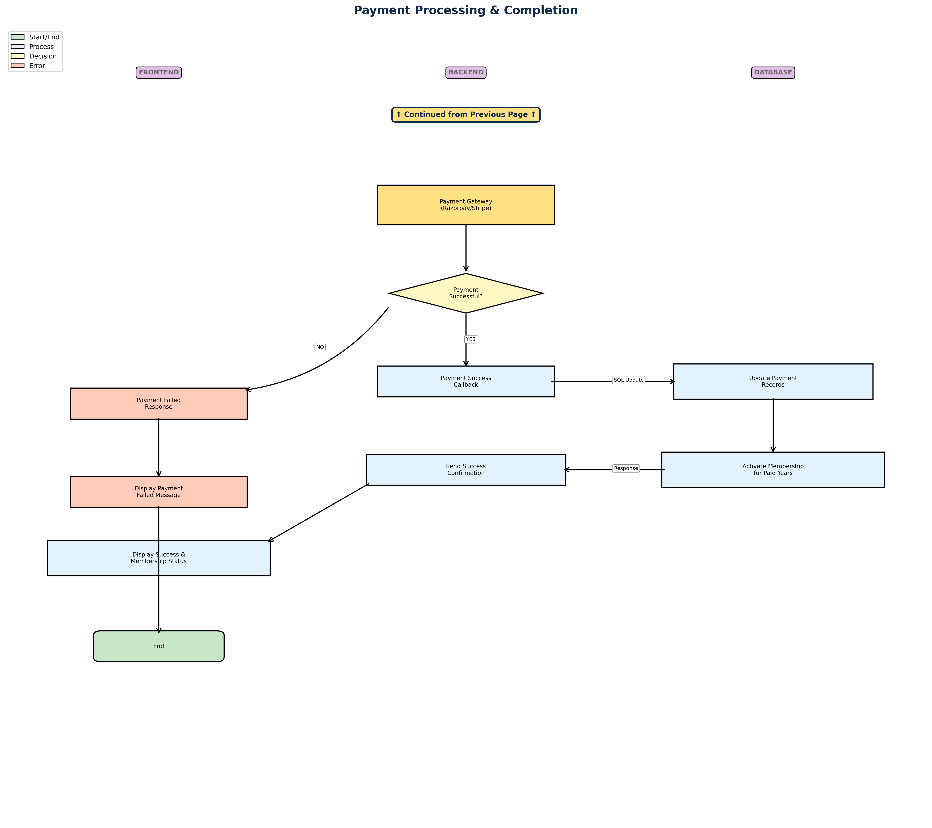

3.1 Flow Description
User Access & Search: User visits the website and searches for a member by name. The frontend sends an API request to the backend, which queries the MySQL database.
Member Verification: If the member is found, their complete details (Name, Phone, Email, Folio Number) are retrieved from the database, formatted by the backend, and displayed on the frontend.
Payment Initiation: When the user proceeds to payment, the system fetches the complete payment history from the database to determine which membership years are payable.
Payment Processing: The user is redirected to the payment gateway. Upon successful payment, the database is updated with new payment records, and the membership is activated for the paid years.

4. PAYMENT LOGIC FLOWCHART
This flowchart focuses specifically on the payment logic and membership year validation. It demonstrates the critical rule that prevents users from skipping membership years, ensuring sequential payment processing.
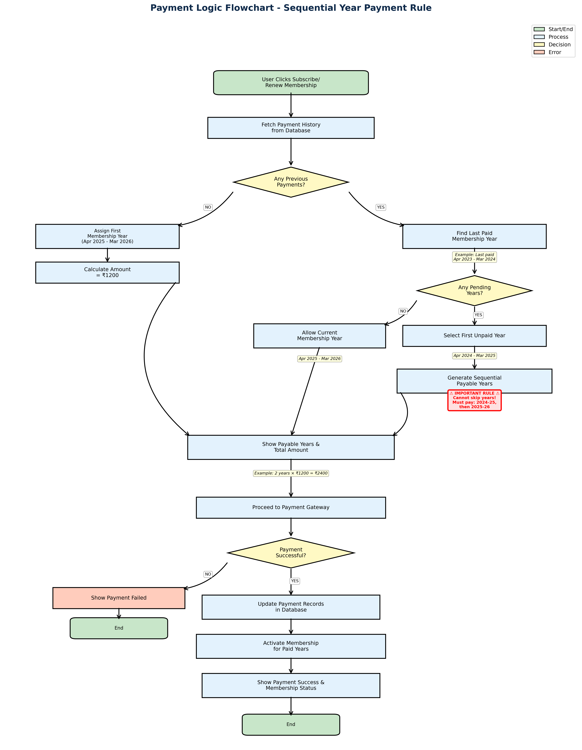

4.1 Payment Logic Description
First-Time Members: If a member has no previous payment history, they are assigned the first membership year (April 2025 - March 2026) with a fee of ₹1,200.
Existing Members with All Payments Up-to-Date: If a member has paid all previous years, they can pay for the current membership year.
Existing Members with Pending Years: If a member has skipped any years, the system identifies the first unpaid year and generates a sequential list of all payable years. The member must pay for all pending years before they can pay for the current year.
Example Scenario: If a member paid for 2022-23 and 2023-24 but skipped 2024-25, they cannot directly pay for 2025-26. They must first pay for 2024-25, and then they can pay for 2025-26. The total amount would be ₹2,400 (2 years × ₹1,200).

5. MEMBERSHIP YEAR RULES

5.1 Year Format
Each membership year runs from April to March (aligned with the financial year). The year format is represented as: Apr YYYY - Mar YYYY+1.

5.2 Membership Year Examples
Membership Years
Apr 2021 - Mar 2022
Apr 2022 - Mar 2023
Apr 2023 - Mar 2024
Apr 2024 - Mar 2025
Apr 2025 - Mar 2026
Apr 2026 - Mar 2027

5.3 Sequential Payment Rule
⚠ CRITICAL RULE: Members cannot skip membership years. All pending years must be paid in sequential order before the current year can be paid. This ensures continuity of membership and prevents gaps in the payment history.

5.4 Membership Fee
The membership fee is ₹1,200 per year.
Total Amount Calculation: Total Amount = Number of Payable Years × ₹1,200

6. DATABASE SCHEMA
The MySQL database consists of two primary tables for managing member information and payment records.

6.1 Members Table
Field | Type | Description
id | INT | Primary key, auto-increment
name | VARCHAR(255) | Member full name
phone | VARCHAR(20) | Contact phone number
email | VARCHAR(255) | Email address
folio_number | VARCHAR(50) | Unique folio identification number
created_at | DATETIME | Record creation timestamp

6.2 Membership Payments Table
Field | Type | Description
id | INT | Primary key, auto-increment
member_id | INT | Foreign key to members.id
membership_year_start | DATE | Start date of membership year (April)
membership_year_end | DATE | End date of membership year (March)
amount | DECIMAL(10,2) | Payment amount (₹1200)
payment_status | VARCHAR(20) | Status: pending, success, failed
payment_date | DATETIME | Date and time of payment
transaction_id | VARCHAR(100) | Payment gateway transaction ID

7. API ENDPOINTS
The backend Node.js API provides the following RESTful endpoints for the frontend application.
Method | Endpoint | Description
POST | /api/members/search | Search for a member by name. Returns member details or 404 if not found.
GET | /api/members/:id | Get complete member details by member ID including folio number.
GET | /api/payments/history/:memberId | Fetch complete payment history for a member including all paid years.
POST | /api/payments/calculate | Calculate payable years and total amount based on payment history.
POST | /api/payments/initiate | Initiate payment gateway transaction and return payment URL.
POST | /api/payments/verify | Verify payment callback from gateway and update database records.
POST | /api/membership/activate | Activate membership for paid years after successful payment.

8. USER JOURNEY
This section describes the step-by-step user journey through the membership payment system.

8.1 Member Search Phase
Step 1: User visits the website and navigates to the member search page.
Step 2: User enters member name in the search field and clicks search.
Step 3: System displays member details if found, or shows 'Member Not Found' error if not found.

8.2 Member Verification Phase
Step 4: User reviews displayed member details:
• Full Name
• Phone Number
• Email Address
• Folio Number (Important for identification)

8.3 Payment Selection Phase
Step 5: User clicks 'Subscribe' or 'Renew Membership' button.
Step 6: System fetches payment history and calculates payable years based on the sequential payment rule.
Step 7: System displays:
• List of payable membership years
• Number of years to be paid
• Total payment amount (Years × ₹1,200)

8.4 Payment Processing Phase
Step 8: User clicks 'Proceed to Payment' button.
Step 9: User is redirected to the payment gateway (Razorpay/Stripe).
Step 10: User completes payment using their preferred payment method.
Step 11: System processes payment callback:
If Successful: Updates payment records, activates membership for paid years, and displays success message.
If Failed: Displays payment failed message and allows user to retry.

8.5 Important Notes
Payment Security: All payment transactions are processed through secure payment gateways with industry-standard encryption.
Transaction Records: Every payment transaction is recorded in the database with a unique transaction ID for future reference.
Membership Status: Members can check their current membership status and payment history at any time from their account.
Email Notifications: Members receive email confirmation for successful payments and membership activation.
END OF DOCUMENT
For inquiries or support, please contact Sunsys Technologies Pvt Ltd

